Website Comments
7/12/2023

Font: Raleway Bold for Titles and Raleway Regular for paragraphs and subtitles
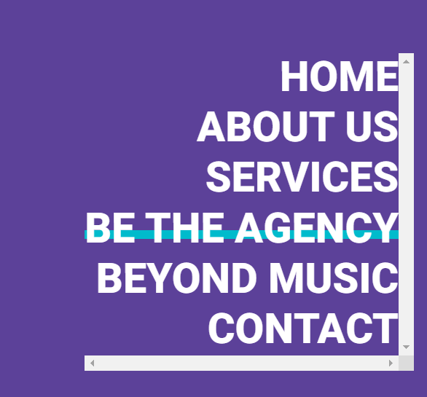
Menu: Please make the blue line in the menu yellow

HOMEPAGE
- Headers:
- When they click “Get to know us” it should redirect them to the “About us” page
- Same for “Know more” for Production and content creation when they click it it takes them to the production page or the content creation page
- Is it possible to remove the yellow lines in the header?

- Showcases:
- Yellow line for IQ Awards to be adjusted

- Our Goals:
- Change “Our goals” font size to 35px and change color to purple please

ABOUT US
- “Our Story” font size 60px
- “We believe that the market…” font size 30px
- “And Beyond was established…” font size 15px
I made an adjustment for nancy’s photo, so if we can please make the text next to it white instead of purple

- Above the team member we need to add a title similar to the “Showcases” but write instead “Start Engine”
- The employees’ names should be Purple
- Remove the social icons under each employee
- Make the background light purple #b7a4cf instead of grey

SERVICES

- The below pictures is a reference of how the layout should be similar to the 3 columns template but since they are 7, I add the last on on the right
Production:
- Make the space between the lines of the paragraph a little bit bigger
- Make the font Regular not bold

Content Creation | Graphics & Animation | Digital Media | Artist & Event Management | Digital Distribution | Original formats :
- Make the font size similar to the one in “Production”

BE THE AGENCY
- I updated the header on the server
- Font size of the paragraph please similar to the ones in the services
- Add social media icons as floating button on the right if possible

BEYOND MUSIC
- Font size of the paragraph please similar to the ones in the services
- Center the social media icons
- Add social media icons as floating button on the right if possible

CONTACT
- No comments for now

